Chapter 9
Exercises
9.3 (Using Composition Rather Than Inheritance)
Many programs written with inheritance could be written with composition instead, and vice versa. Rewrite class BasePlusCommissionEmployee (Fig. 9.11) of the CommissionEmployee–BasePlusCommissionEmployee hierarchy to use composition rather than inheritance.
9.4 (Software Reuse)
Discuss the ways in which inheritance promotes software reuse, saves time during program development and helps prevent errors.

Answer;
1. Promotes Software Reuse
- Inheritance allows developers to reuse existing code instead of writing it again.
- Common attributes and methods are defined once in the superclass and automatically inherited by subclasses.
- This reduces duplication and makes programs more organized.
Example:
If CommissionEmployee already contains methods such as earnings() and toString(), BasePlusCommissionEmployee can inherit these methods instead of rewriting them.
2. Saves Development Time
- Developers can build new classes by extending existing ones rather than starting from scratch.
- Only new or specialized features need to be added in the subclass.
- Less coding results in faster software development and easier project completion.
Example:
A Manager class can inherit from an Employee class and only add manager-specific attributes, such as a bonus or department.
3. Helps Prevent Errors
- Reusing tested and debugged code reduces the likelihood of introducing new bugs.
- Since the superclass has already been verified, subclasses inherit reliable functionality.
- Changes made to the superclass automatically benefit all subclasses, ensuring consistency throughout the program.
4. Improves Maintainability
- Shared code exists in one place, making updates easier.
- If a common method needs modification, it is changed only in the superclass rather than in multiple classes.
- This simplifies maintenance and reduces inconsistencies.
5. Supports Extensibility
- New subclasses can be created without modifying existing code.
- This allows software to grow and adapt to new requirements while preserving existing functionality.
6. Encourages Logical Class Hierarchies
- Inheritance models real-world "is-a" relationships, making programs easier to understand.
- For example:
  - Employee → CommissionEmployee → BasePlusCommissionEmployee
  - Vehicle → Car, Truck, Bus

9.5 (Student Inheritance Hierarchy)
Draw an inheritance hierarchy for students at a university similar to the hierarchy shown in Fig. 9.2.
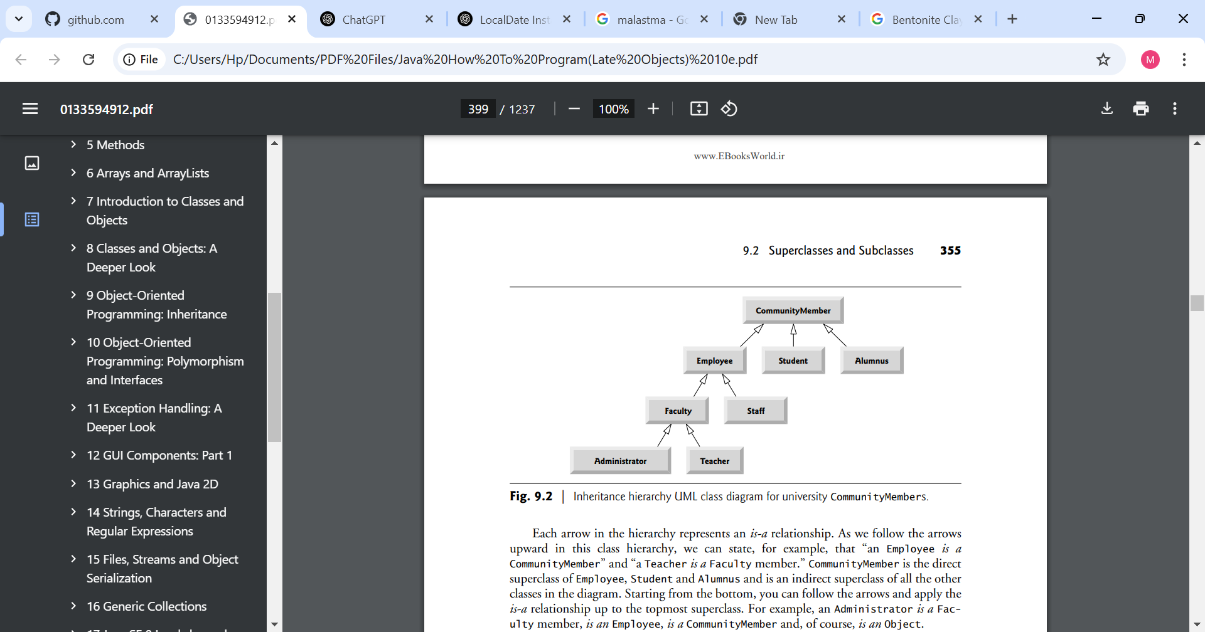Use Student as the superclass of the hierarchy, then extend Student with classes UndergraduateStudent and GraduateStudent. Continue to extend the hierarchy as deep (i.e., as many levels) as possible. For example, Freshman, Sophomore, Junior and Senior might extend UndergraduateStudent, and DoctoralStudent and MastersStudent might be subclasses of GraduateStudent. After drawing the hierarchy, discuss the relationships that exist between the classes. [Note: You do not need to write any code for this exercise.]
Answer:
Student
│
┌────────────────────┴────────────────────┐
│ │
UndergraduateStudent GraduateStudent
│ │
┌──────┼──────┬──────┬──────┐ ┌─────────┴─────────┐
│ │ │ │ │ │
Freshman Sophomore Junior Senior MastersStudent DoctoralStudent
│ │
┌─────────┴──────┐ ┌────┴─────────┐
│ │ │ │
ThesisMasters CourseBased PhDStudent ProfessionalDoctorate
│
ResearchMasters
Relationships Between the Classes
- Student is the superclass (base class) of the hierarchy. It contains attributes and behaviors common to all students, such as:
  - Student ID
  - Name
  - Age
  - Address
  - Program
  - Methods like registerCourse(), payFees(), and viewTranscript().
- UndergraduateStudent and GraduateStudent are subclasses of Student.
  - They inherit all the common features of Student.
  - They also introduce characteristics specific to undergraduate or graduate education.
- Freshman, Sophomore, Junior, and Senior are subclasses of UndergraduateStudent.
  - Each represents a different academic level.
  - They inherit all properties of both Student and UndergraduateStudent.
  - They may include additional rules, such as credit-hour requirements for promotion.
- MastersStudent and DoctoralStudent are subclasses of GraduateStudent.
  - Both inherit graduate student characteristics while adding their own specialized features.
- ThesisMasters, CourseBased, and ResearchMasters further specialize MastersStudent.
  - A ThesisMasters student must complete a research thesis.
  - A CourseBased student focuses primarily on coursework.
  - A ResearchMasters student emphasizes research with limited coursework.
- PhDStudent and ProfessionalDoctorate specialize DoctoralStudent.
  - PhDStudent focuses on original research and dissertation work.
  - ProfessionalDoctorate (such as EdD or DBA) combines advanced coursework with applied research.
Type of Relationship
The hierarchy represents an "is-a" relationship:
- A Freshman is a Student.
- A Senior is an UndergraduateStudent.
- A MastersStudent is a GraduateStudent.
- A PhDStudent is a DoctoralStudent.
- A DoctoralStudent is a GraduateStudent.
- A GraduateStudent is a Student.
Because of inheritance, every subclass automatically receives the attributes and methods of its parent class while adding its own specialized features. This promotes code reuse, reduces duplication, and makes the system easier to maintain and extend.

9.6 (Shape Inheritance Hierarchy)
The world of shapes is much richer than the shapes included in the inheritance hierarchy of Fig. 9.3.
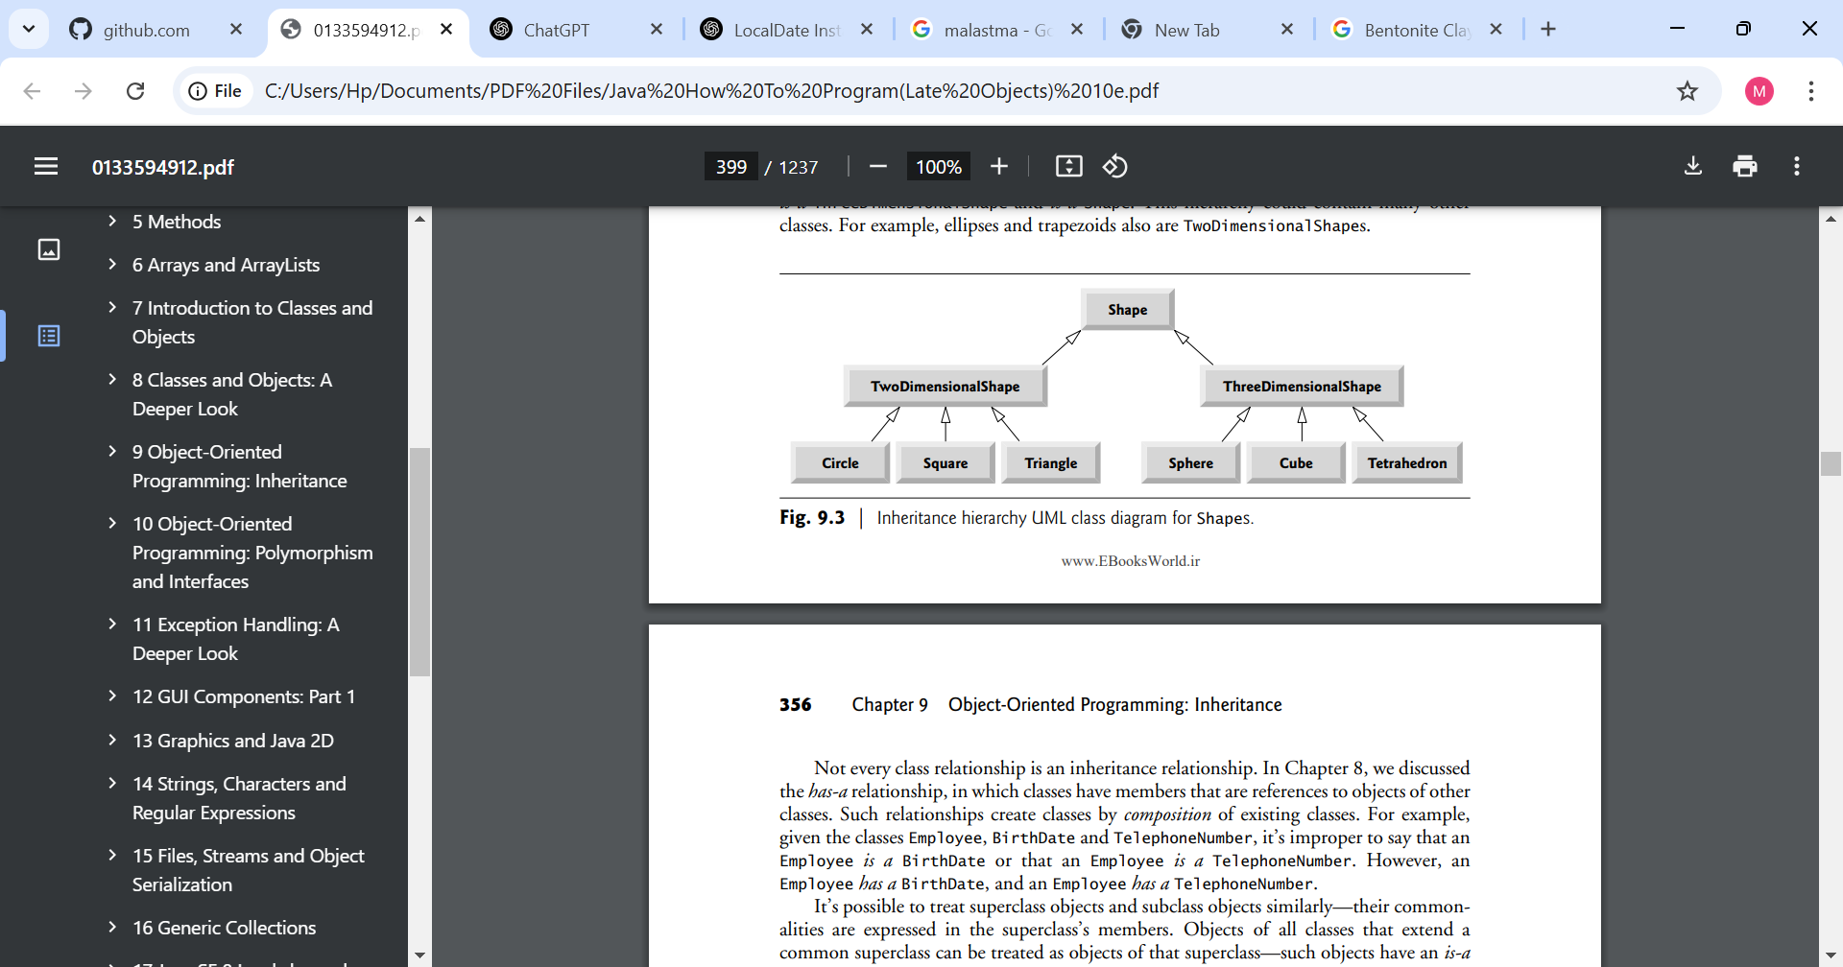
Write down all the shapes you can think of—both two-dimensional and three-dimensional—and form them into a more complete Shape hierarchy with as many levels as possible. Your hierarchy should have class Shape at the top. Classes TwoDimensionalShape and ThreeDimensionalShape should extend Shape. Add additional subclasses, such as Quadrilateral and Sphere, at their correct locations in the hierarchy as necessary.

Answer:
Shape
│
┌────────────────────┴────────────────────┐
│ │
TwoDimensionalShape ThreeDimensionalShape
│ │
┌─────────┼──────────┐ ┌───────────────┼────────────────┐
│ │ │ │ │ │
Polygon Ellipse Line Polyhedron CurvedSolid Surface
│ │ │ │
│ ├──────────────┐ │ ├──────────────┐
│ │ │ │ │ │
│ Circle Ellipse Prism Sphere Ellipsoid
│ │
├───────────────┬──────────────┐ ├──────────────┐
│ │ │ │ │
Triangle Quadrilateral Pentagon RectangularPrism TriangularPrism
│ │
│ ┌─────┼──────────────┬─────────────┐
│ │ │ │ │
Equilateral Rectangle Parallelogram Trapezoid
Triangle │ │
Isosceles ├───────────┐ Rhombus
Triangle │ │
Scalene Square Rectangle
Triangle
Explanation of the Hierarchy
1. Shape (Superclass)
- The root of the hierarchy.
- Contains properties common to all shapes, such as:
  - Color
  - Position
  - Methods like draw(), calculateArea(), or calculateVolume() (where applicable).

2. TwoDimensionalShape
Represents flat shapes that have:
- Length and width
- Area
- Perimeter
- No volume
Examples include:
- Circle
- Ellipse
- Triangle
- Rectangle
- Square
- Rhombus
- Trapezoid
- Pentagon
- Hexagon
- Octagon

3. ThreeDimensionalShape
Represents solid objects that have:
- Length
- Width
- Height
- Surface area
- Volume
Examples include:
- Sphere
- Cube
- Cuboid (Rectangular Prism)
- Cylinder
- Cone
- Pyramid
- Prism
- Tetrahedron
- Ellipsoid
- Torus

Relationships Between the Classes
This hierarchy demonstrates inheritance ("is-a") relationships.
Examples include:
- A Circle is an Ellipse.
- An Ellipse is a TwoDimensionalShape.
- A Square is a Rectangle.
- A Rectangle is a Quadrilateral.
- A Quadrilateral is a Polygon.
- A Polygon is a TwoDimensionalShape.
- A Cube is a RectangularPrism.
- A RectangularPrism is a Prism.
- A Prism is a Polyhedron.
- A Sphere is a ThreeDimensionalShape.
Each subclass inherits the characteristics of its parent class while adding more specialized properties or behaviors.
Benefits of This Hierarchy
- Code reuse: Common properties and methods are defined once in Shape or intermediate classes.
- Reduced duplication: Shared functionality is inherited instead of rewritten.
- Easy maintenance: Changes to a superclass automatically affect all subclasses.
- Extensibility: New shapes (e.g., Heptagon, Cylinder, or Cone) can be added without modifying existing classes.
This hierarchy is deeper and more comprehensive than the one in the textbook, demonstrating how inheritance organizes shapes from the most general (Shape) to the most specific (e.g., Square, Sphere, Cube, EquilateralTriangle).

9.7 (protected vs. private)
Some programmers prefer not to use protected access, because they believe it breaks the encapsulation of the superclass. Discuss the relative merits of using protected access vs. using private access in superclasses.
Answer:
protected and private are two access modifiers used to control how superclass data and methods are accessed by subclasses. Each has advantages and disadvantages.
Protected Access | Private Access
Allows subclasses to access superclass members directly. | Prevents subclasses from directly accessing superclass members.
Makes it easier to extend classes. | Preserves strong encapsulation and data hiding.
Reduces the need for getter and setter methods. | Requires access through public or protected methods (getters/setters).
Can improve performance slightly by avoiding method calls. | Ensures the superclass controls how its data is accessed and modified.
May allow subclasses to accidentally modify inherited data incorrectly. | Reduces the risk of accidental or unauthorized modification.
Merits of Using protected
- Simplifies subclass development
  - Subclasses can directly use inherited fields and methods without writing additional accessor methods.
- Reduces code
  - Less boilerplate code is required because subclasses do not need numerous getter and setter methods.
- Useful for closely related classes
  - When subclasses are trusted and tightly related to the superclass, protected can make implementation easier.
Disadvantage: Direct access may allow subclasses to change data in ways that violate the superclass's intended rules or invariants.

Merits of Using private
- Maintains encapsulation
  - Data is hidden from subclasses and other classes.
  - The superclass has complete control over its internal state.
- Improves reliability
  - Validation can be performed in setter methods before values are changed.
- Makes maintenance easier
  - The internal implementation of the superclass can change without affecting subclasses, as long as its public or protected methods remain the same.
- Prevents unintended errors
  - Subclasses cannot accidentally corrupt the superclass's data by modifying fields directly.
Disadvantage: More accessor and mutator methods may be required, resulting in additional code.

Which Is Better?
In most object-oriented designs, private is preferred because it preserves encapsulation, one of the core principles of object-oriented programming. Subclasses should interact with superclass data through well-defined methods rather than directly accessing fields.
protected is appropriate when subclasses genuinely need direct access to certain members and the superclass designer intends those members to be part of the inheritance interface. However, it should be used sparingly because it exposes implementation details and increases coupling between the superclass and its subclasses.

9.8 (Quadrilateral Inheritance Hierarchy)
Write an inheritance hierarchy for classes Quadrilateral, Trapezoid, Parallelogram, Rectangle and Square. Use Quadrilateral as the superclass of the hierarchy. Create and use a Point class to represent the points in each shape. Make the hierarchy as deep (i.e., as many levels) as possible. Specify the instance variables and methods for each class. The private instance variables of Quadrilateral should be the x-y coordinate pairs for the four endpoints of the Quadrilateral. Write a program that instantiates objects of your classes and outputs each object’s area (except Quadrilateral).
9.9 (What Does Each Code Snippet Do?)
a) Assume that the following method call is located in an overridden earnings method in a subclass:
super.earnings()
b) Assume that the following line of code appears before a method declaration:
@Override
c) Assume that the following line of code appears as the first statement in a constructor’s body:
super(firstArgument, secondArgument);

Answer:
a) super.earnings()
- Calls the earnings() method of the superclass (parent class).
- It is often used in an overridden method to reuse the parent's implementation before adding or modifying behavior in the subclass.
Example:
@Override
public double earnings() {
return super.earnings() + bonus;
}

b) @Override
- Indicates that the method below it is intended to override a method in the superclass.
- It helps the compiler detect mistakes. If there is no matching method in the superclass, the compiler reports an error.
Example:
@Override
public double earnings() {
return salary;
}

c) super(firstArgument, secondArgument);
- Calls the constructor of the superclass with the specified arguments.
- It must be the first statement in the subclass constructor.
- It initializes the inherited fields defined in the parent class.
Example:
public Employee(String name, int id) {
super(name, id);
}
Here, super(name, id) calls the constructor of the superclass to initialize the name and id fields.

9.10 (Write a Line of Code)
Write a line of code that performs each of the following tasks:
a) Specify that class PieceWorker inherits from class Employee.
b) Call superclass Employee’s toString method from subclass PieceWorker’s toString method.
c) Call superclass Employee’s constructor from subclass PieceWorker’s constructor—assume that the superclass constructor receives three Strings representing the first name, last name and social security number.

Specify that class PieceWorker inherits from class Employee:
public class PieceWorker extends Employee

b) Call superclass Employee's toString() method from subclass PieceWorker's toString() method:
super.toString()
Example:
@Override
public String toString() {
return super.toString() + "\nPiece Worker details";
}

c) Call superclass Employee's constructor from subclass PieceWorker's constructor:
super(firstName, lastName, socialSecurityNumber);
Example:
public PieceWorker(String firstName, String lastName, String socialSecurityNumber) {
super(firstName, lastName, socialSecurityNumber);
}

9.11 (Using super in a Constructor’s Body)
Explain why you would use super in the first statement of a subclass constructor’s body.
Answer;
You use super as the first statement in a subclass constructor’s body to call the superclass’s constructor and initialize the inherited fields of the subclass object.
A subclass inherits variables and methods from its superclass, but it does not directly initialize the superclass’s private data. The super() call allows the subclass constructor to pass values to the parent class constructor so that the inherited part of the object is properly created before the subclass adds its own initialization.
Example:
public class Employee {
private String firstName;
private String lastName;

public Employee(String firstName, String lastName) {
this.firstName = firstName;
this.lastName = lastName;
}
}
Subclass:
public class PieceWorker extends Employee {

public PieceWorker(String firstName, String lastName) {
super(firstName, lastName); // calls Employee constructor
}
}
Here, super(firstName, lastName); initializes the Employee part of the PieceWorker object.
Reasons for using super first:
- It initializes inherited superclass variables.
- It avoids duplicating superclass initialization code.
- Java requires the superclass constructor call to happen before any other statements in a subclass constructor.

9.12 (Using super in an Instance Method’s Body)
Explain why you would use super in the body of a subclass’s instance method.
Answer:
You use super inside a subclass’s instance method to call a method from the superclass that has been overridden in the subclass.
It allows the subclass to reuse the superclass’s version of the method instead of replacing it completely.
Example:
@Override
public String toString() {
return super.toString() + "\nHourly Employee details";
}
Here, super.toString() calls the parent class’s toString() method.

9.13 (Calling get Methods in a Class’s Body)
In Figs. 9.10–9.11 methods earnings and toString each call various get methods within the same class. Explain the benefits of calling these get methods within the classes.
Answer:
Calling get methods inside a class’s methods (such as earnings() and toString()) has several benefits:
- Encapsulation
  - The class controls access to its private data.
  - Direct access to instance variables is avoided.
- Easier maintenance
  - If the implementation of a variable changes, only the get method needs to change.
- Improved readability
  - Methods like getFirstName() clearly show what data is being retrieved.
- Allows validation
  - A get method can include additional checks or processing before returning data.
Example:
return getFirstName() + " " + getLastName();
is preferred over:
return firstName + " " + lastName;
because it follows good object-oriented programming practices.

9.14 (Employee Hierarchy)
In this chapter, you studied an inheritance hierarchy in which class BasePlusCommissionEmployee inherited from class CommissionEmployee. However, not all types of employees are CommissionEmployees. In this exercise, you’ll create a more general Employee superclass that factors out the attributes and behaviors in class CommissionEmployee that are common to all Employees. The common attributes and behaviors for all Employees are firstName, lastName, socialSecurityNumber, getFirstName, getLastName, getSocialSecurityNumber and a portion of method toString. Create a new superclass Employee that contains these instance variables and methods and a constructor. Next, rewrite class CommissionEmployee from Section 9.4.5 as a subclass of Employee. Class CommissionEmployee should contain only the instance variables and methods that are not declared in superclass Employee. Class CommissionEmployee’s constructor should invoke class Employee’s constructor and CommissionEmployee’s toString method should invoke Employee’s toString method. Once you’ve completed these modifications, run the CommissionEmployeeTest and BasePlusCommissionEmployeeTest apps using these new classes to ensure that the apps still display the same results for a CommissionEmployee object and BasePlusCommissionEmployee object, respectively.
9.15 (Creating a New Subclass of Employee)
Other types of Employees might include SalariedEmployees who get paid a fixed weekly salary, PieceWorkers who get paid by the number of pieces they produce or HourlyEmployees who get paid an hourly wage with time-and-a-half—1.5 times the hourly wage—for hours worked over 40 hours.
Create class HourlyEmployee that inherits from class Employee (Exercise 9.14) and has instance variable hours (a double) that represents the hours worked, instance variable wage (a double) that represents the wages per hour, a constructor that takes as arguments a first name, a last name, a social security number, an hourly wage and the number of hours worked, set and get methods for manipulating the hours and wage, an earnings method to calculate an HourlyEmployee’s earnings based on the hours worked and a toString method that returns the HourlyEmployee’s String representation. Method setWage should ensure that wage is nonnegative, and setHours should ensure that the value of hours is between 0 and 168 (the total number of hours in a week). Use class HourlyEmployee in a test program that’s similar to the one in Fig. 9.5.

